Lesson 7 – Project Instructions (Custom, using Vite in Visual Studio)
This document is customized from your uploaded rubric, assignment instructions, topics covered, and starter App.jsx. It provides numbered steps, code you can paste, and a rubric‑mapping checklist. Tooling: Visual Studio 2022, Node.js, Vite, React, HTML, CSS, JavaScript.

How to use this document
Follow Sections A–D in order. Where you see a placeholder box, paste a screenshot or write notes. If your instructor updates the rubric, paste the new image in the Rubric section and update the mapping table.

A. Your Uploads (for reference)

Screenshot 2025-10-06 134916.png
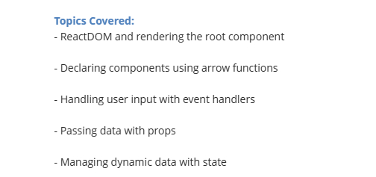

Screenshot 2025-10-06 134930.png
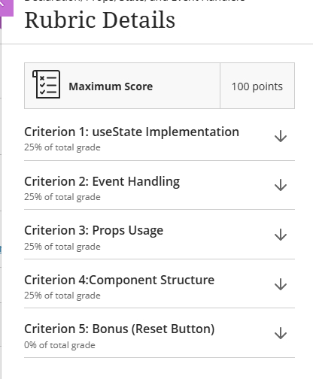

Screenshot 2025-10-06 134832.png
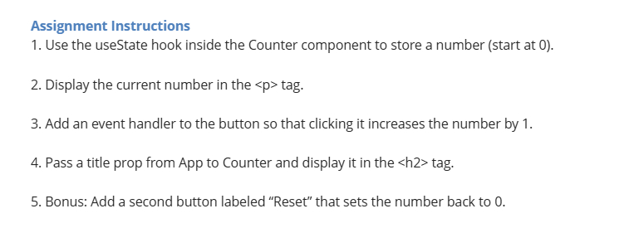

Screenshot 2025-10-06 134900.png
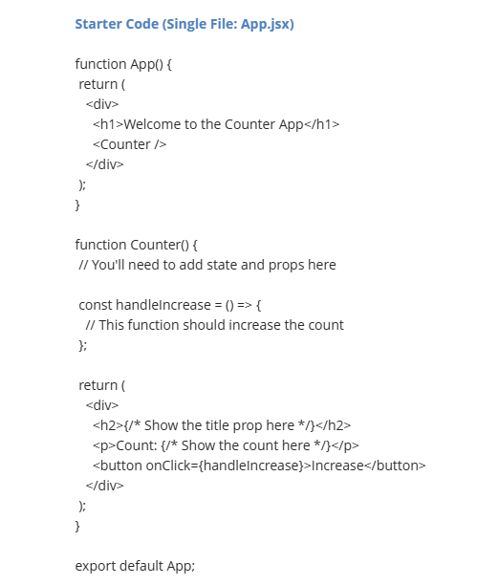

B. Step-by-step Build (Vite + Visual Studio)
These steps scaffold a React app with Vite, then connect it to the DOM with createRoot and wrap in <StrictMode>. Finally, you’ll add components for props, state, and events.
- Install Node.js LTS (Node 20+ recommended). In a terminal, verify: node -v and npm -v.
- Install Visual Studio 2022. In Tools → Get Tools and Features…, add the Node.js development tools (or ASP.NET and web development).
- Open Visual Studio → File → Open → Folder… → choose/create a folder for this project.
- Open Terminal inside Visual Studio (View → Terminal) and run:
npm create vite@latest my-lesson7-app -- --template react
cd my-lesson7-app
npm install
npm run dev
- Open the printed local URL (typically http://localhost:5173) to confirm the Vite starter runs.

Project structure
index.html
src/
main.jsx
App.jsx
index.css
components/
Greeting.jsx
Counter.jsx
InputMirror.jsx

index.html
<!doctype html>
<html>
<head>
<meta charset="UTF-8" />
<meta name="viewport" content="width=device-width, initial-scale=1.0" />
<title>Lesson 7 Project</title>
</head>
<body>
<div id="root"></div>
<script type="module" src="/src/main.jsx"></script>
</body>
</html>

src/main.jsx (ReactDOM createRoot + <StrictMode>)
import React from 'react'
import { createRoot } from 'react-dom/client'
import App from './App.jsx'
import './index.css'
createRoot(document.getElementById('root')).render(
<React.StrictMode>
<App />
</React.StrictMode>
)

Components (props, state, events)
Create src/components/Greeting.jsx
export default function Greeting({ name = 'Student' }) {
return <h2>Hello, {name}!</h2>
}
Create src/components/Counter.jsx
import { useState } from 'react'
export default function Counter({ initial = 0 }) {
const [count, setCount] = useState(initial)
const inc = () => setCount(c => c + 1)
const dec = () => setCount(c => c - 1)
return (
<div className="card">
<p>Count: {count}</p>
<button onClick={dec}>-</button>
<button onClick={inc}>+</button>
</div>
)
}
Create src/components/InputMirror.jsx
import { useState } from 'react'
export default function InputMirror() {
const [text, setText] = useState('')
function handleChange(e) {
setText(e.target.value)
}
return (
<div>
<input value={text} onChange={handleChange} placeholder="Type here..." />
<p>You typed: {text}</p>
</div>
)
}

src/App.jsx (compose your UI)
import Greeting from './components/Greeting.jsx'
import Counter from './components/Counter.jsx'
import InputMirror from './components/InputMirror.jsx'
export default function App() {
const studentName = 'Gregory'
return (
<>
<h1>Lesson 7 Project</h1>
<Greeting name={studentName} />
<Counter initial={0} />
<InputMirror />
</>
)
}

src/index.css (minimal styles)
:root {
font-family: system-ui, -apple-system, 'Segoe UI', Roboto, Arial, sans-serif;
line-height: 1.5;
}
.card { display: inline-flex; align-items: center; gap: 0.5rem; }
button { padding: 0.5rem 0.75rem; }

Run & Debug in Visual Studio
- Run: npm run dev (Terminal).
- Optional: Install the NPM Task Runner extension to run scripts from Task Runner Explorer.
- Debugging: set breakpoints in .jsx; attach Chrome/Edge from Visual Studio or use browser DevTools.

C. Starter App.jsx (from your upload)
Below is the uploaded Starter App.jsx for reference (image), followed by a placeholder to paste the exact text version so you can copy/paste into your project. If you provide the .jsx file or paste the code as text, I’ll replace this placeholder with the exact code.
Paste your Starter App.jsx text here (to replace in src/App.jsx):
[PASTE STARTER APP.JSX TEXT HERE]

D. Rubric Alignment & Evidence Log
Use the table to map each rubric item to code locations, screenshots, and notes. The rubric snapshots are included above in Section A.
Rubric criterion (paste exact text) | Step(s) in this doc | Where in code (file & line) | Evidence (screenshot / notes)
Uses ReactDOM.createRoot and wraps <StrictMode> | B → src/main.jsx | src/main.jsx (lines …)
Declares function components (arrow functions) | B → Components | src/components/*.jsx
Handles user input with event handlers | B → InputMirror.jsx | src/components/InputMirror.jsx
Passes data with props | B → Greeting.jsx | src/components/Greeting.jsx
Manages dynamic data with state (useState) | B → Counter.jsx | src/components/Counter.jsx

References
• Vite – Getting Started: https://vite.dev/guide/
• React – createRoot: https://react.dev/reference/react-dom/client/createRoot
• React – <StrictMode>: https://react.dev/reference/react/StrictMode
• Visual Studio – Node.js developer tools & npm management: https://visualstudio.microsoft.com/vs/features/node-js/ ; https://learn.microsoft.com/visualstudio/javascript/npm-package-management

